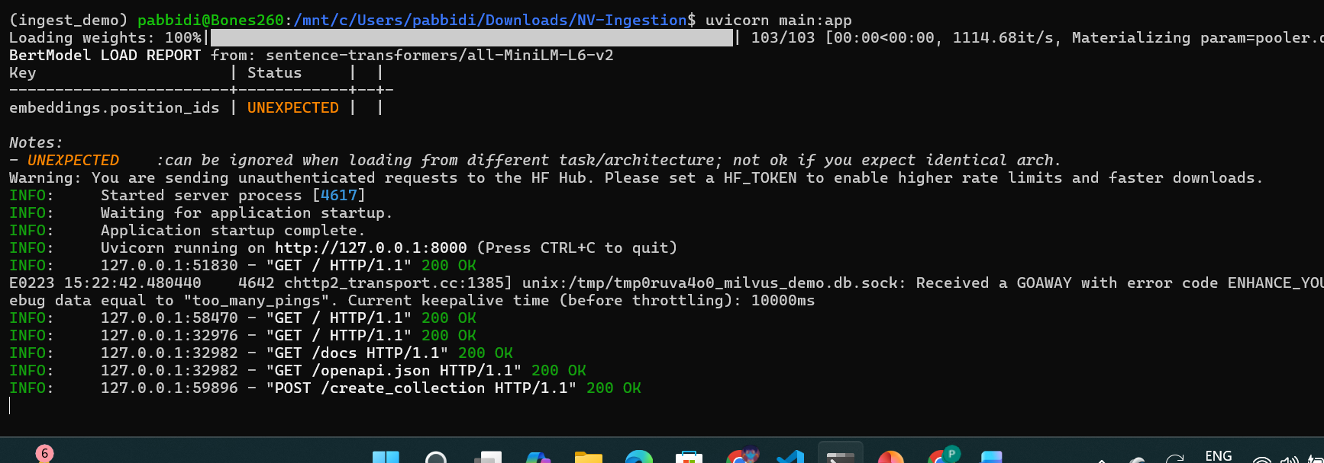
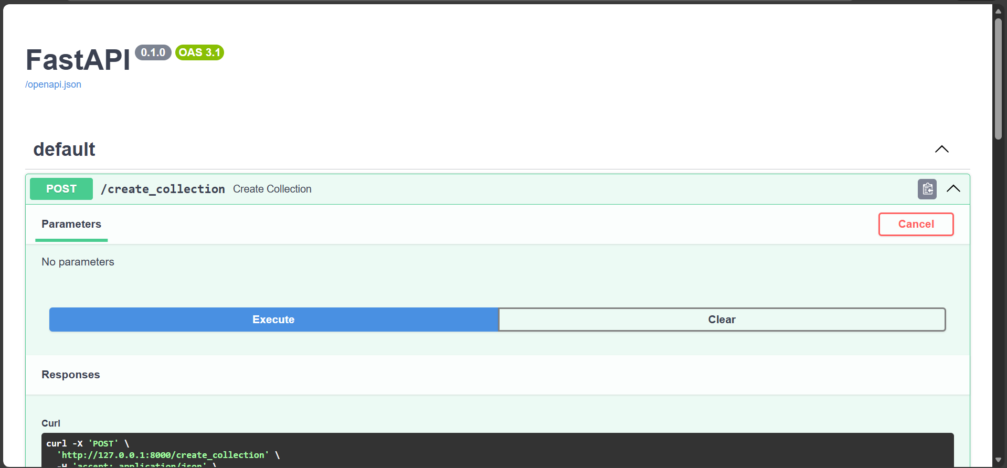
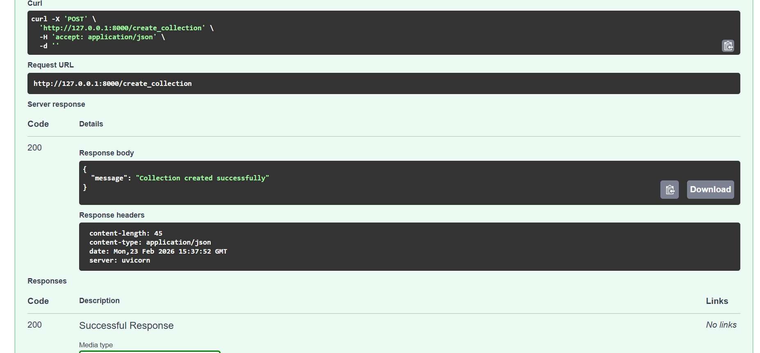
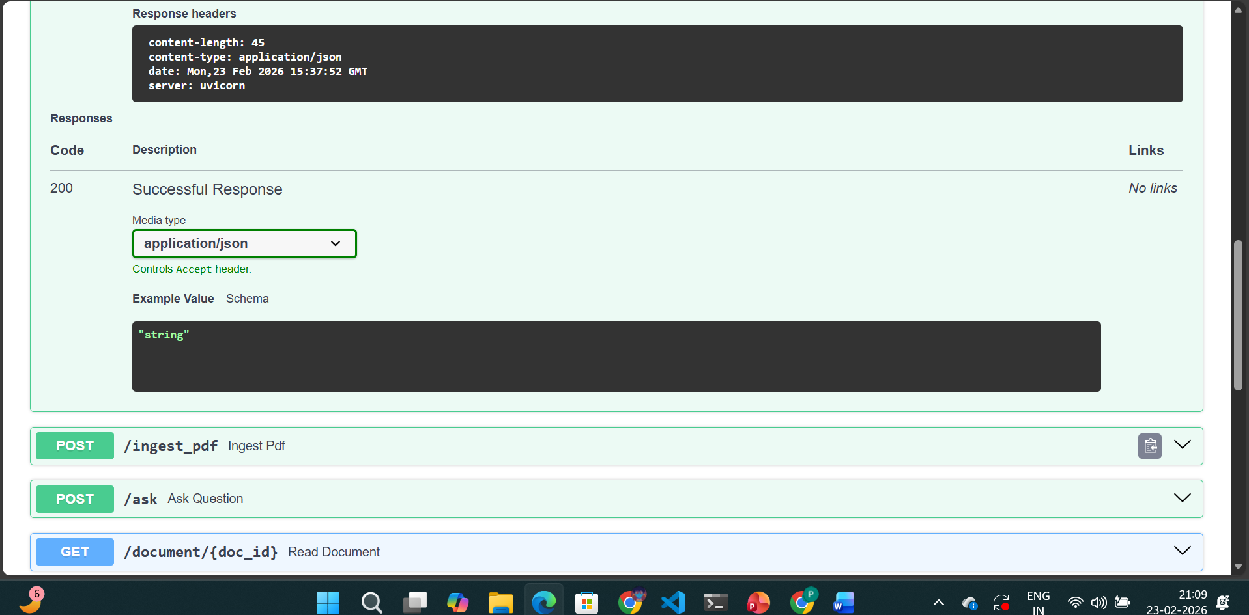
Milvus created a collection:
- Name: pdf_demo
- Dimension: 384
- Primary key: id
- Stored inside: milvus_demo.db

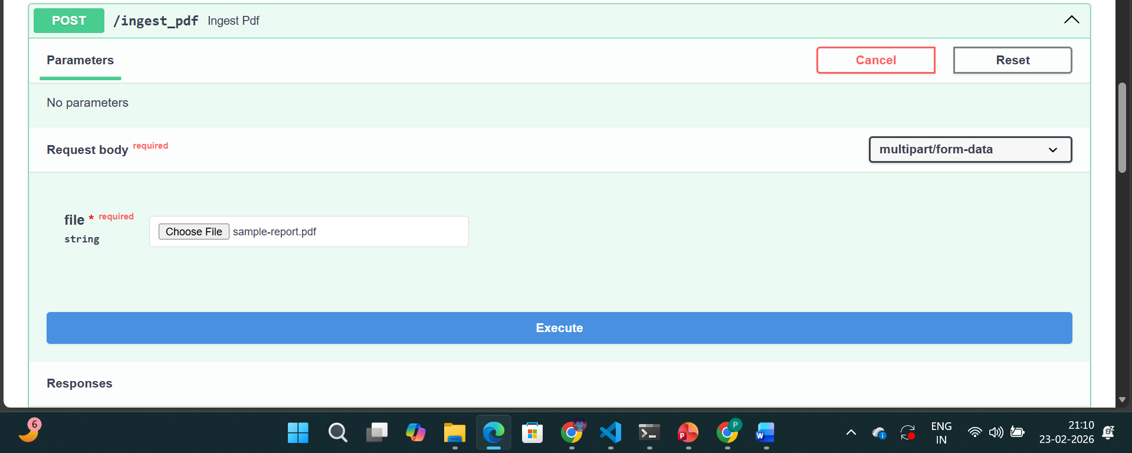
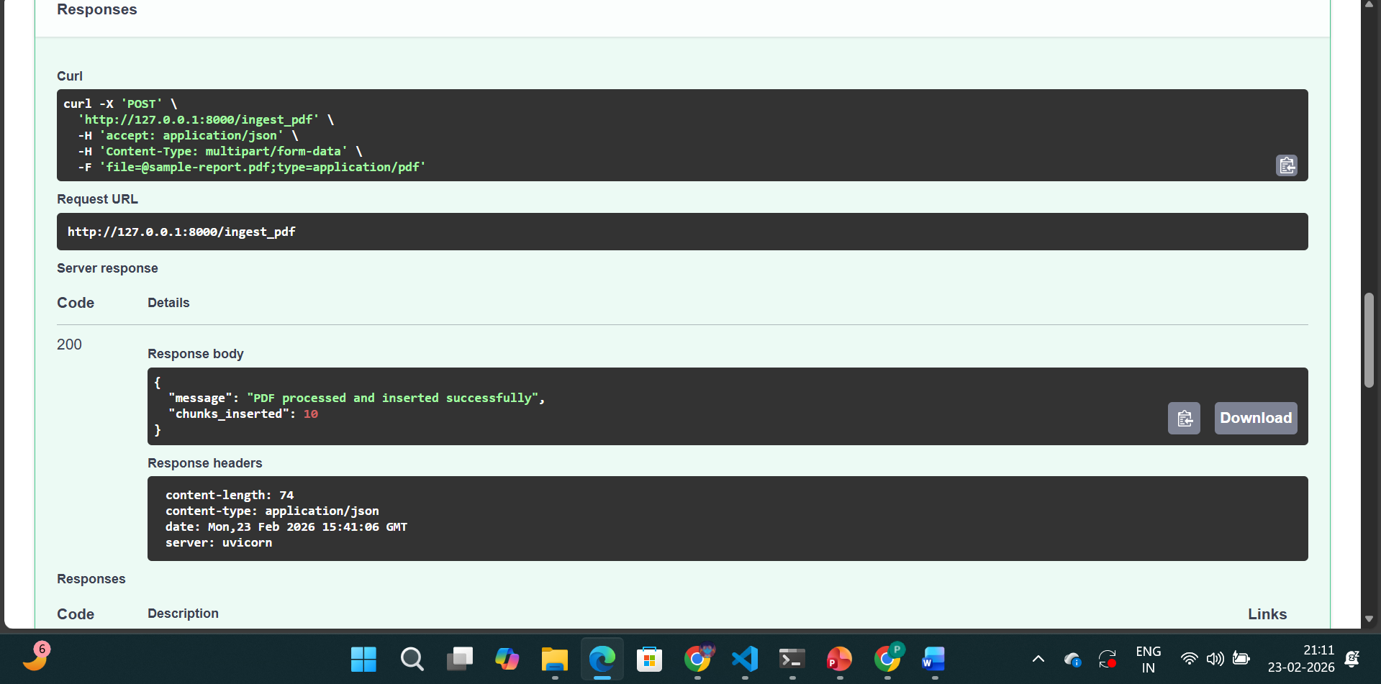
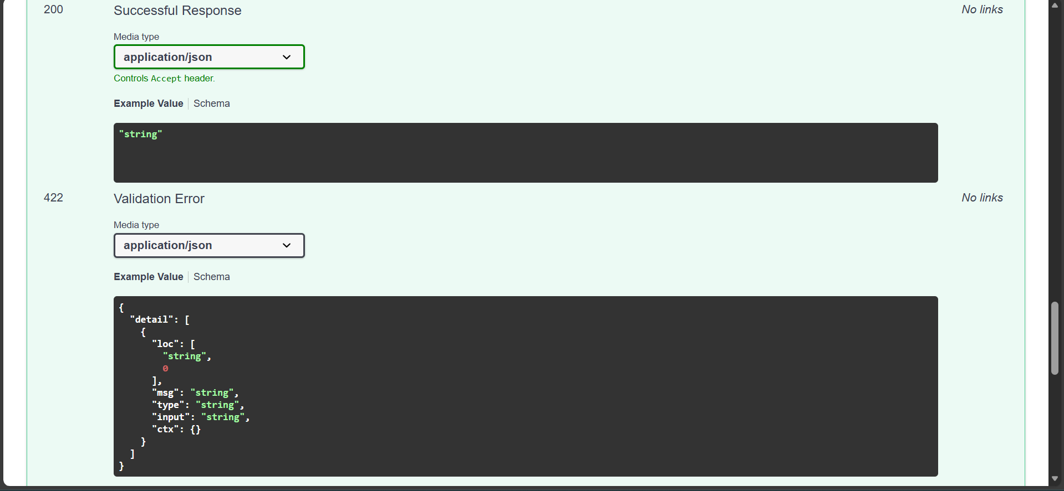
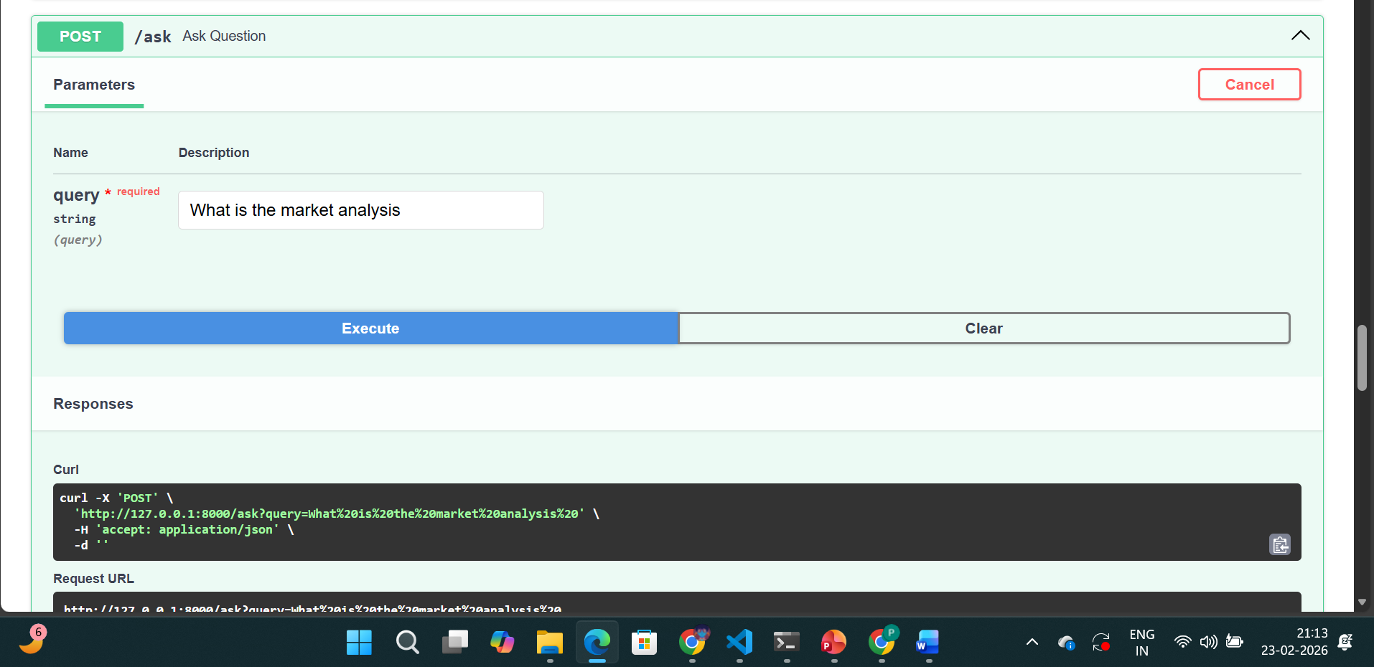
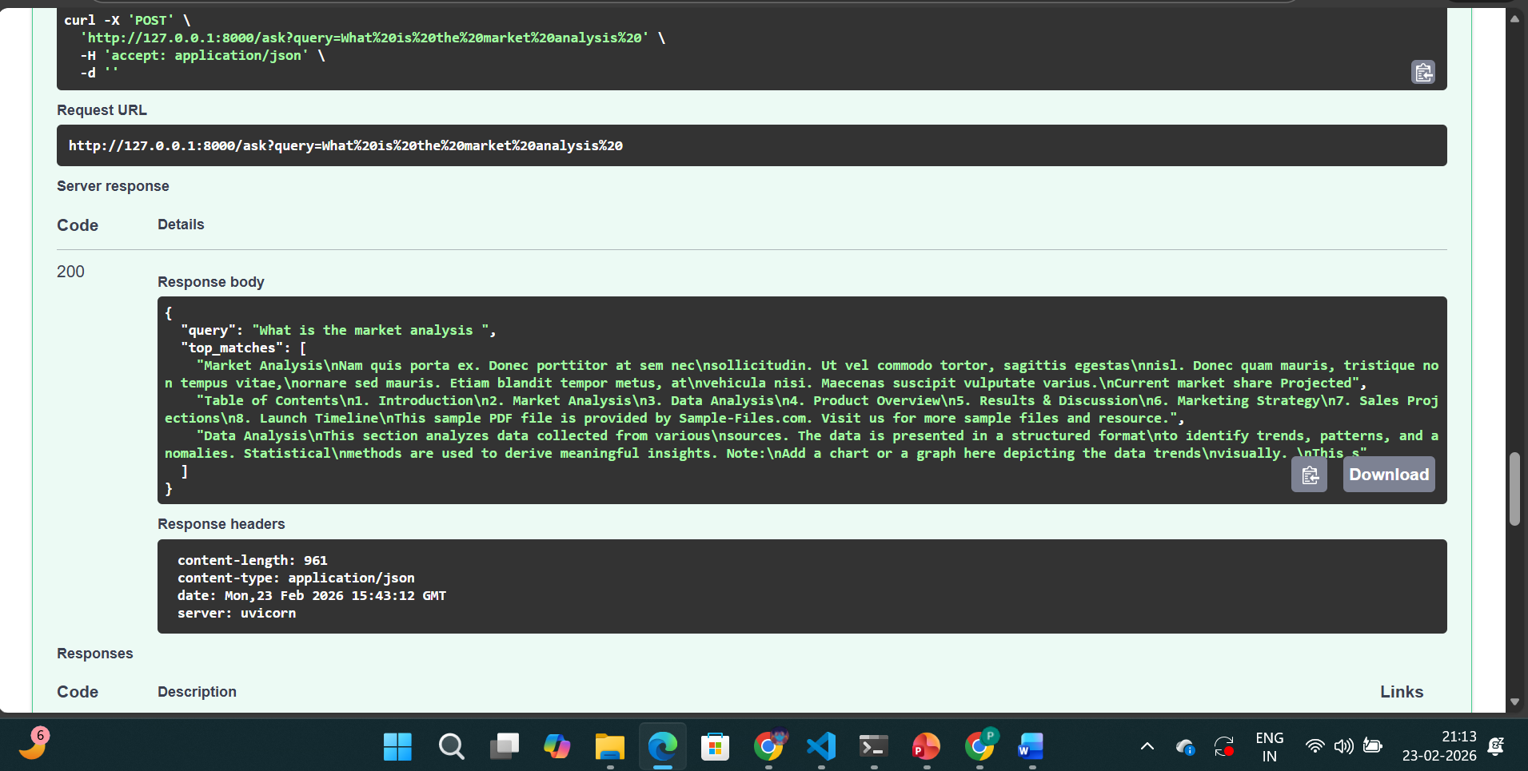
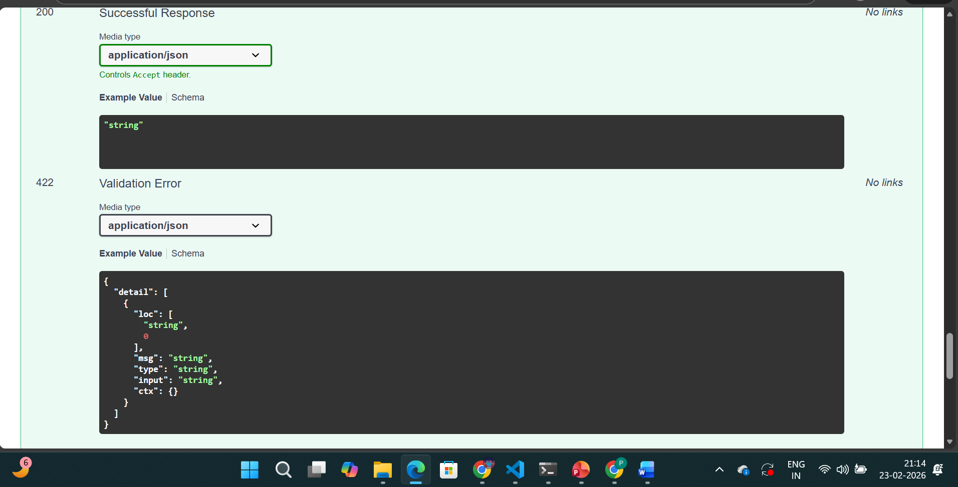
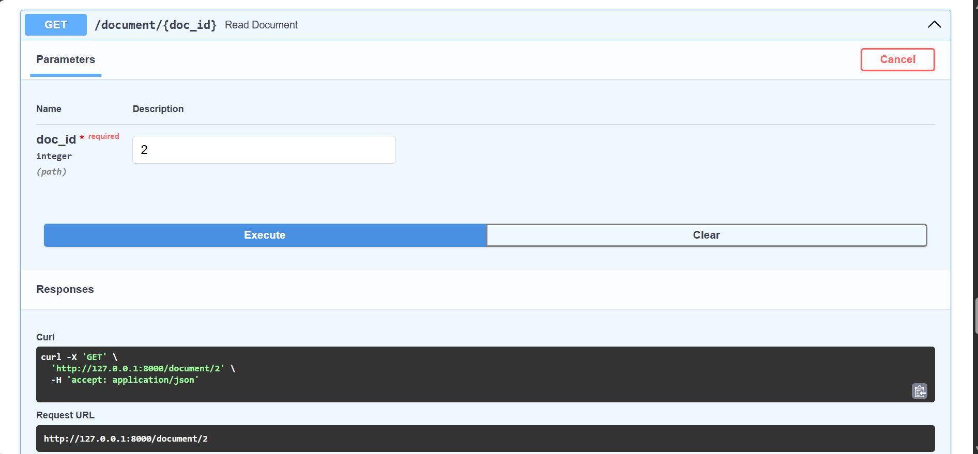
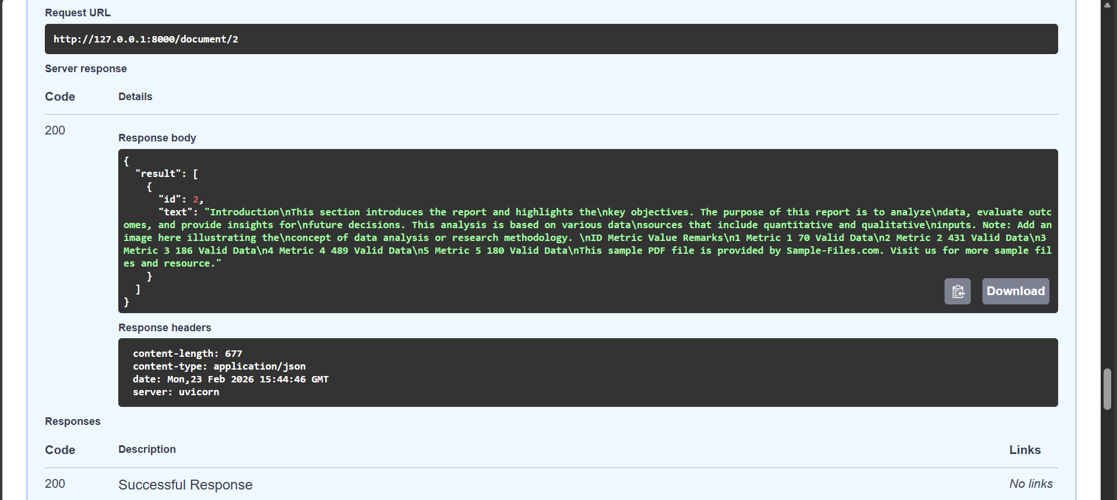
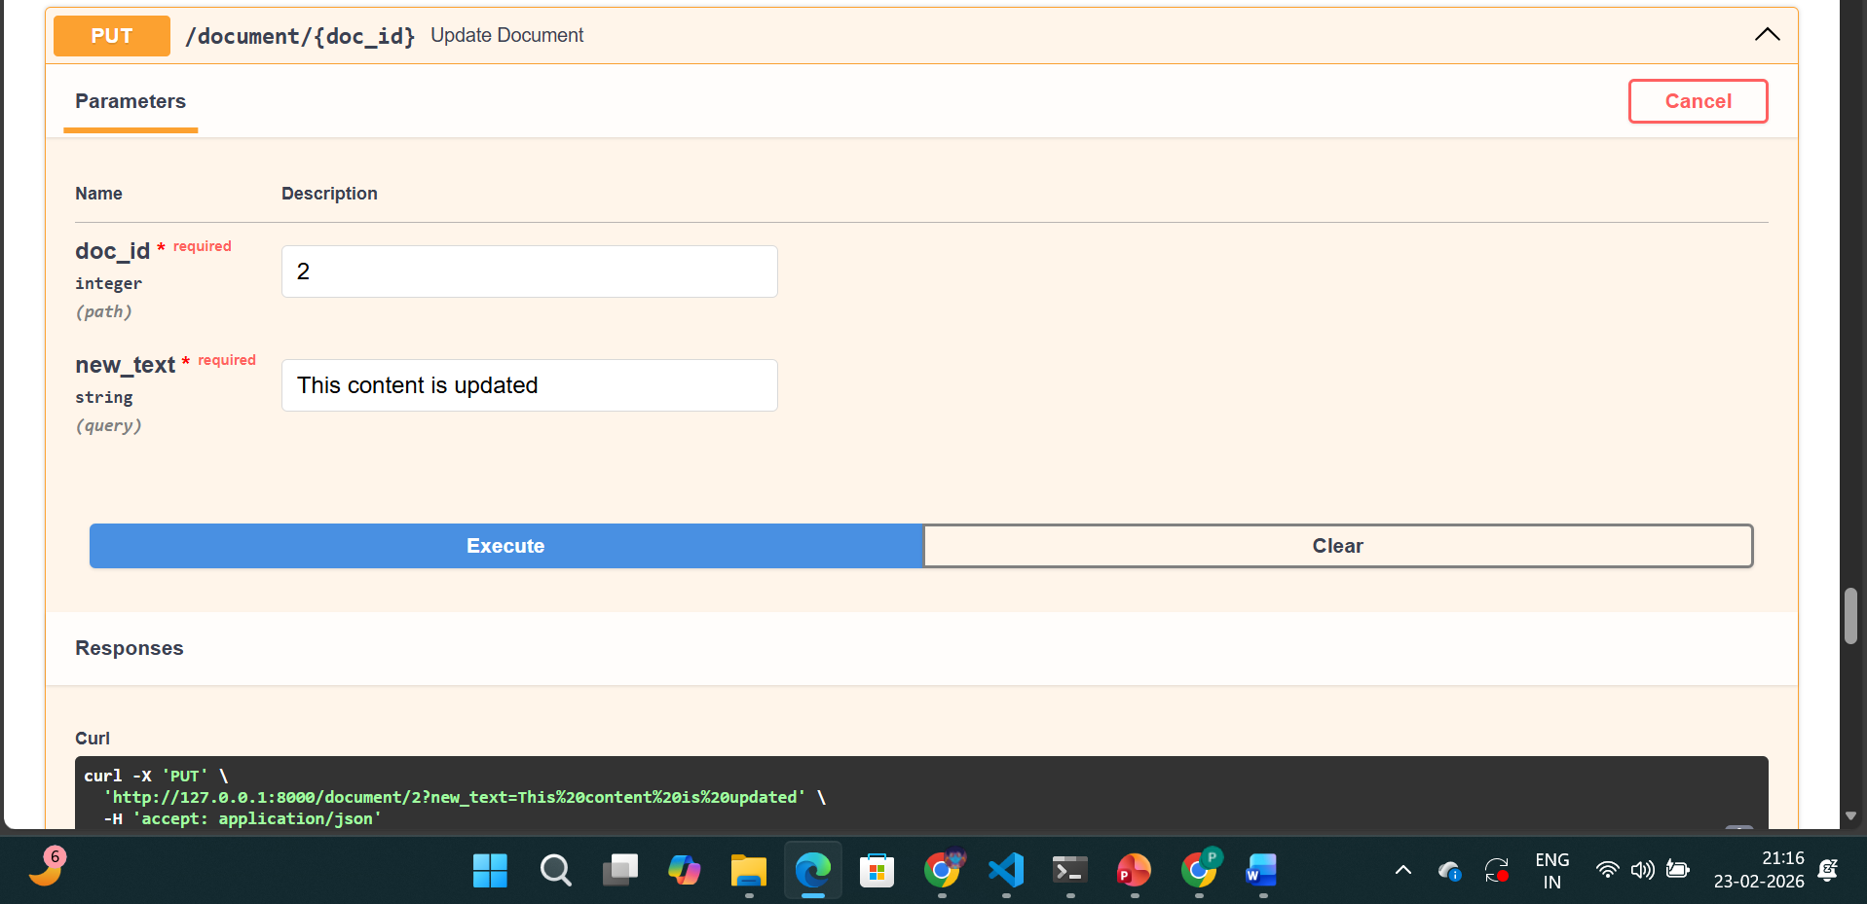
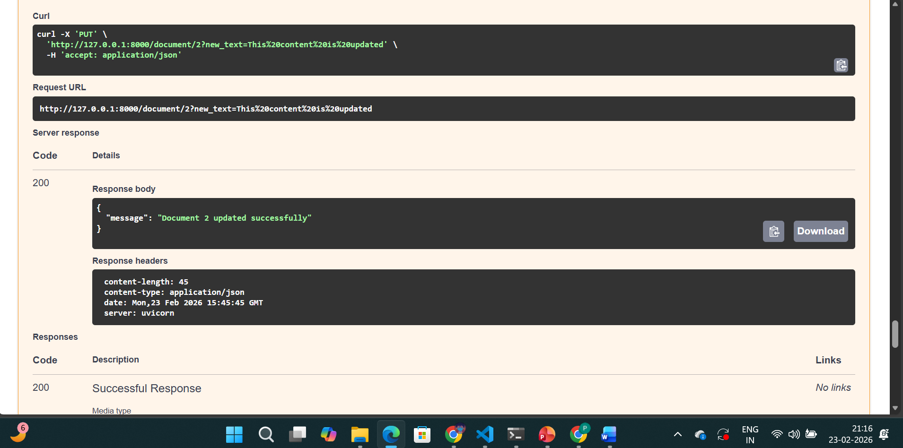
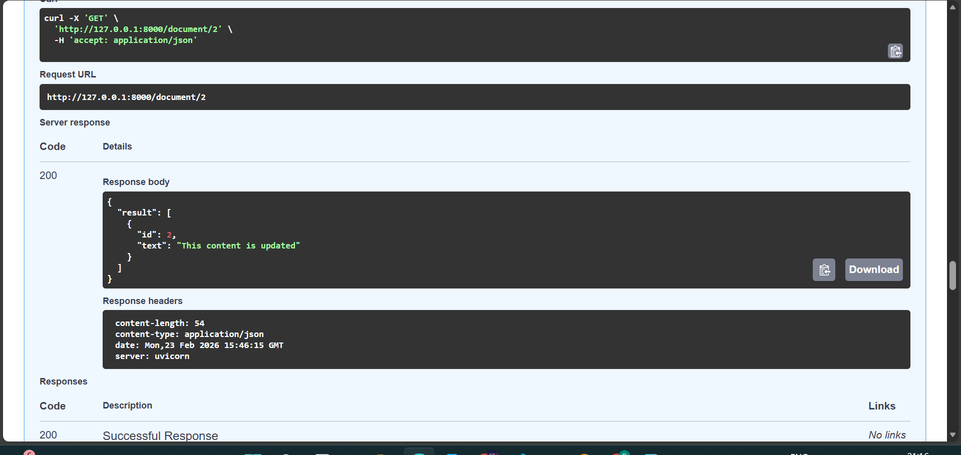
Milvus cannot edit vector directly.
So internally:
- DELETE id=2
- Convert new text → embedding
- INSERT new vector with id=2
This is how vector DB updates.

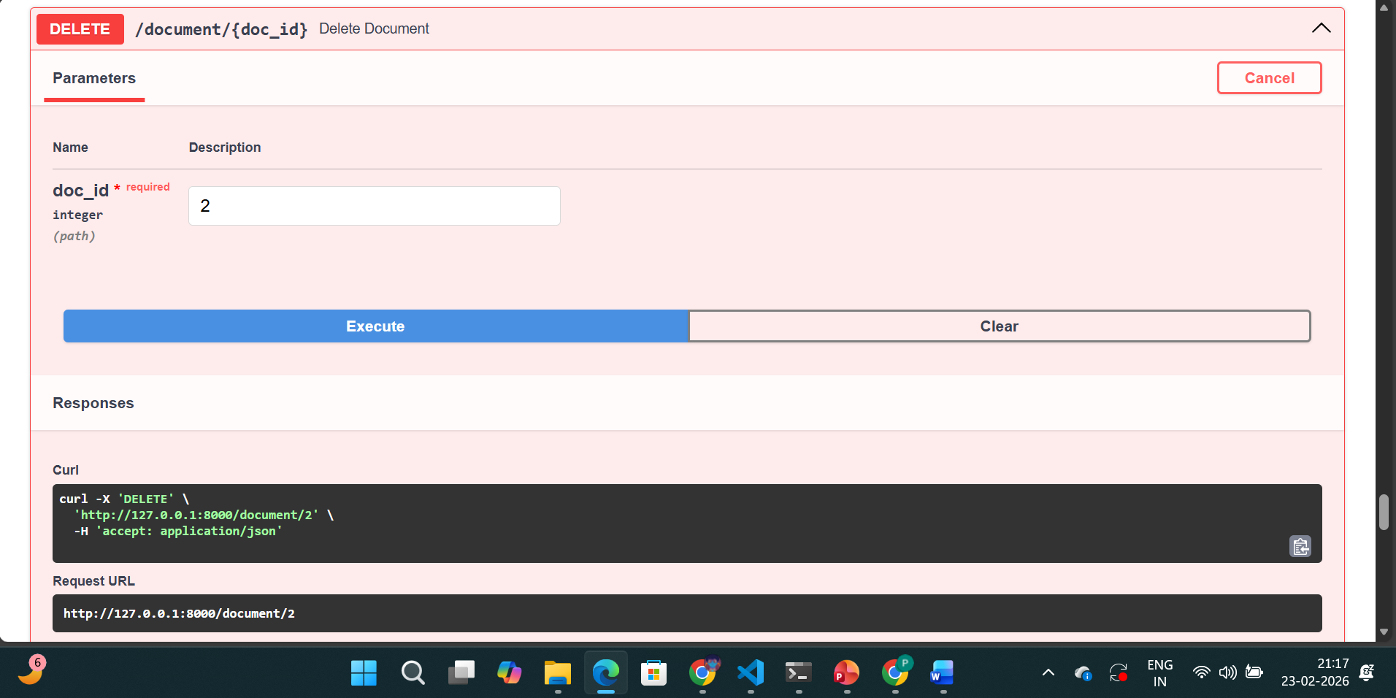
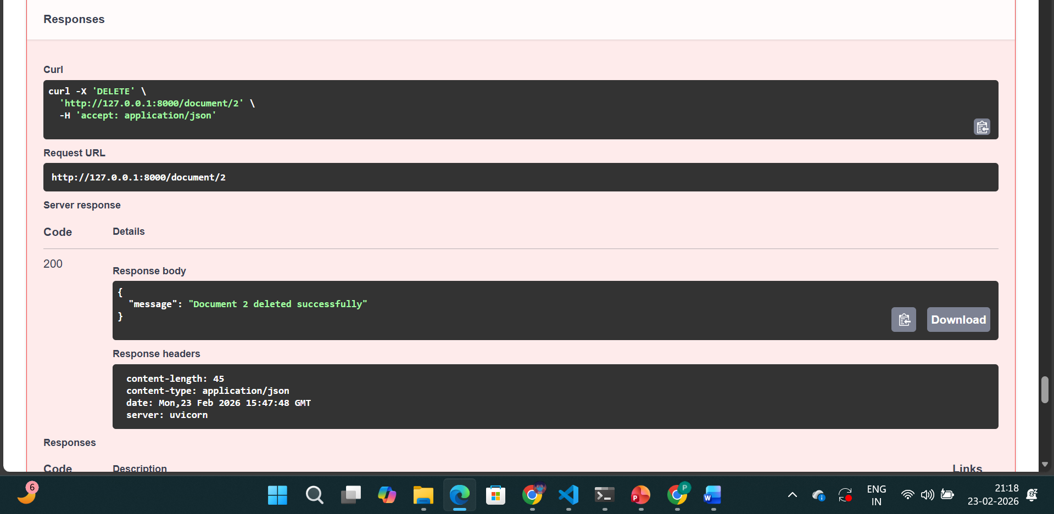
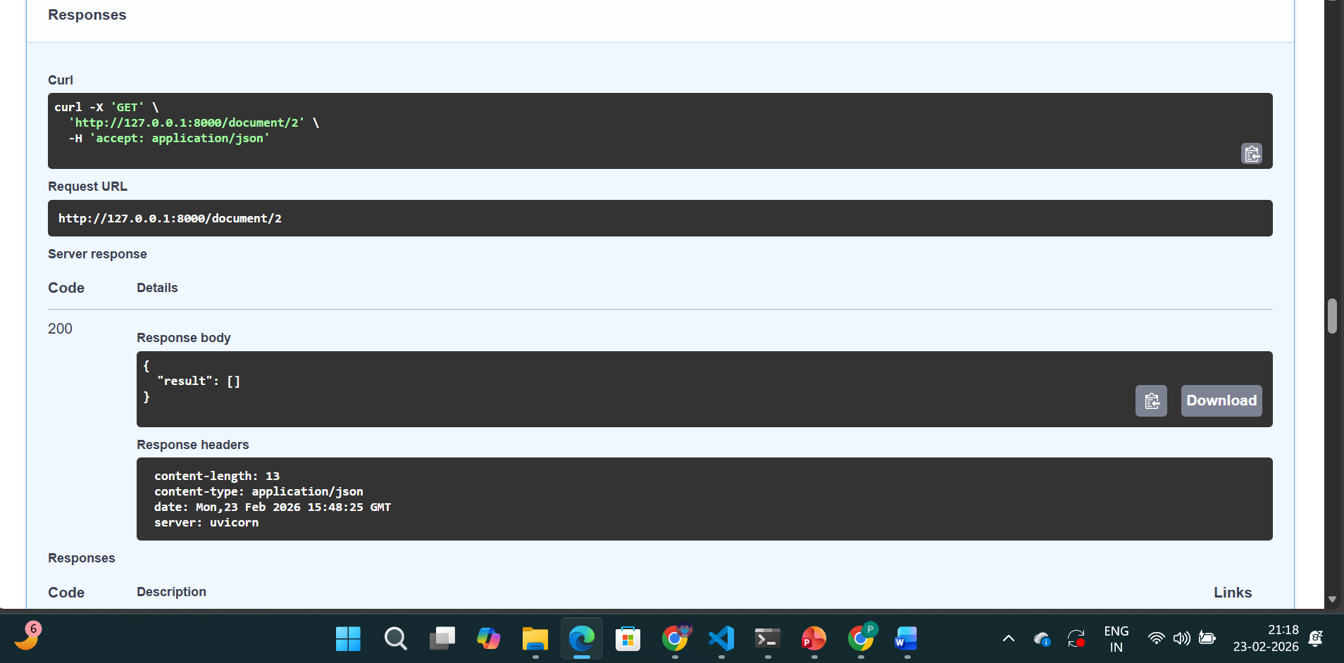
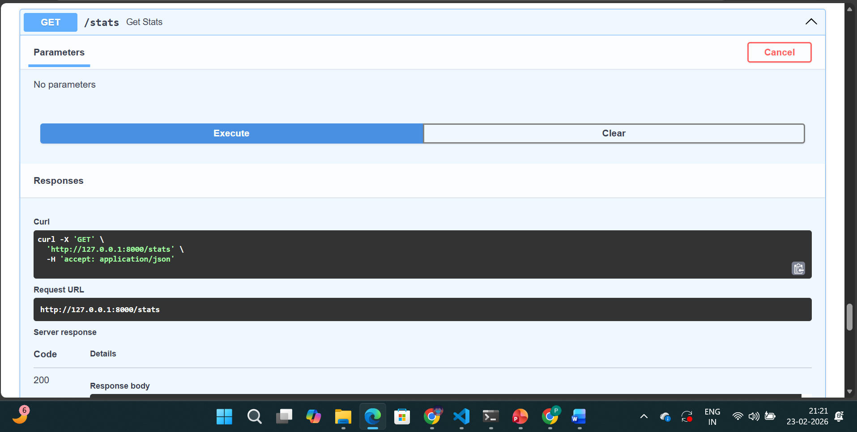
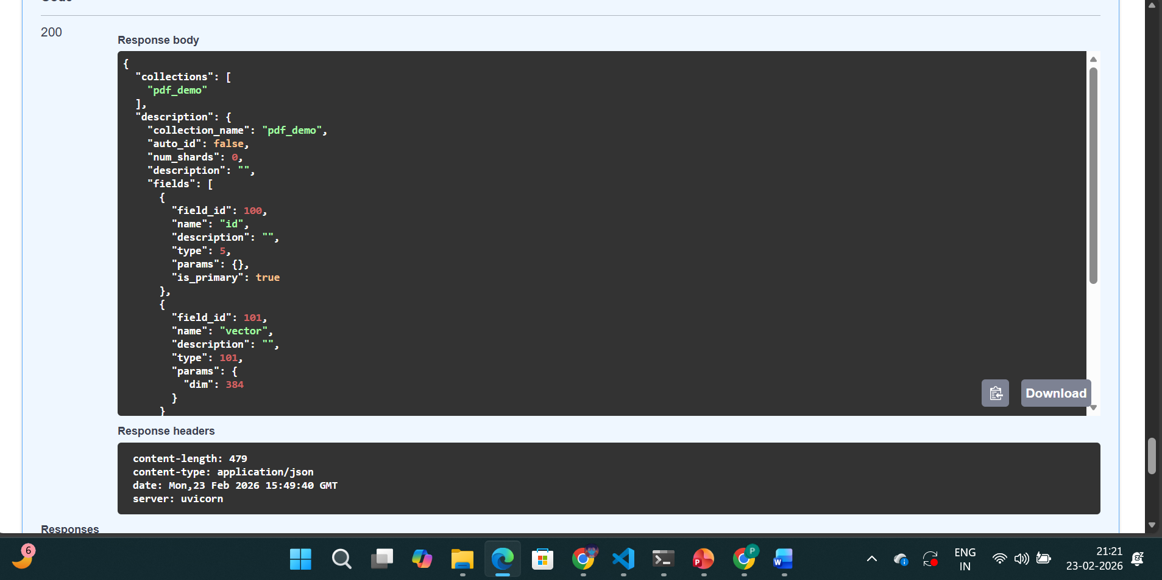

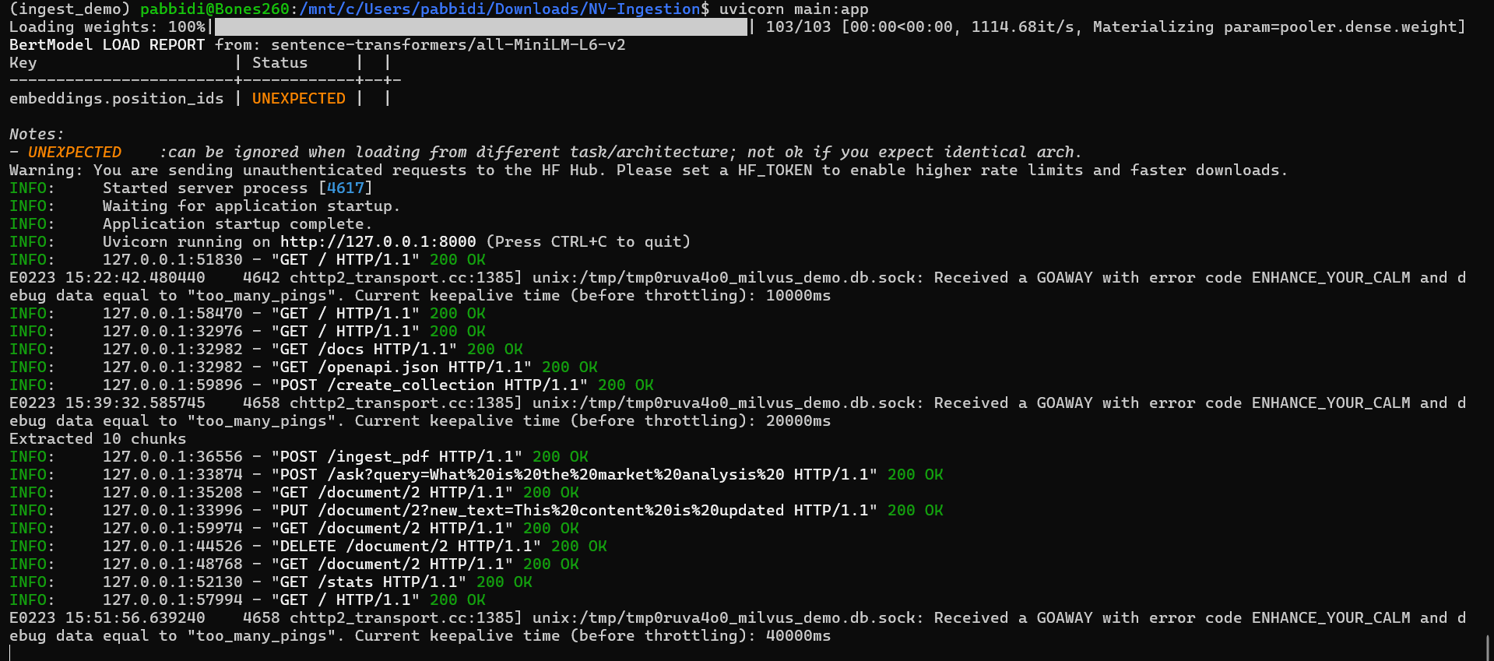
Currently this is a local development setup.
FastAPI exposes vector DB operations as REST APIs.
Milvus Lite stores vectors in a local persistent file.
For production, we deploy it to a server with persistent storage and external IP access.
We wrapped Milvus operations into REST APIs:
- Create → Collection creation
- Insert → PDF ingestion
- Read → Semantic search + direct ID query
- Update → Delete + re-embed + reinsert
- Delete → Remove vector by ID
This makes Milvus accessible as a microservice.

🔹 Why FastAPI?
- Automatic request validation
- RESTful structure
- Swagger documentation
- Easy deployment
- Production ready

Milvus Lite stores data in a file (milvus_demo.db).
- If server stops → API unavailable
- If restarted → data persists
- For production → deploy on cloud server

Method | Meaning
GET | Read-only operation
POST | Create or trigger processing
PUT | Replace existing resource
DELETE | Remove resource

Now this is the important part.
You asked:
If POST is for creating something new, why are we using it for search?
Answer:
POST is used when:
- You send data in request body
- Server performs processing
- Operation is not simple static retrieval
- The request is complex
Your /ask endpoint:
POST /ask
Body:
query = "What is revenue growth?"
What happens?
- You send query text
- Server converts query → embedding
- Milvus performs similarity search
- Returns top matches
This is not just:
“Give me row 5”
This is:
“Process this input and compute something”
So it behaves more like:
“Run this operation”
That is why POST is acceptable for search in ML APIs

